Nereus — Detailed User Journey Flow
Current User Journey and Proposed User Journey | Prepared for Mark Baxter and Keza Studio | 6 October 2026 | Version 1.1

How to read this document
PART A describes the current application as reported in the supplied source reviews. PART B describes recommended fixes, refinements and new journeys. Proposed steps must not be interpreted as available functionality. Current means reported in source evidence, not passed in live functional testing. Unknown behaviour remains explicitly unverified.
Sources: USER_JOURNEY_AND_INFRASTRUCTURE.md; SECURITY_CODE_REVIEW.md; Mark’s initial call/follow-up; Eric’s screen/payment findings; Nereus Application & Technical Review v1.1. Exact UI controls, data requirements and deployed configuration still require a guided walkthrough.
Classification | Meaning
CURRENT — reported | Existing flow described in supplied evidence; live verification still needed.
CURRENT — known gap | Reported defect or incomplete behaviour in the application today.
PROPOSED — fix/refinement | An existing journey corrected or made more dependable.
PROPOSED — new capability | Additional functionality not established as implemented.
UNVERIFIED | Insufficient evidence; neither implementation nor success is assumed.

PART A — Current User Journey Flow
The current core journey is discovery → authentication/onboarding → dashboard → plan and prepare → record fishing activity → review historical patterns. Sharing and Stripe scaffolding exist, but commercial membership enforcement is bypassed. Complete offline synchronisation and a dedicated business admin portal are not established.
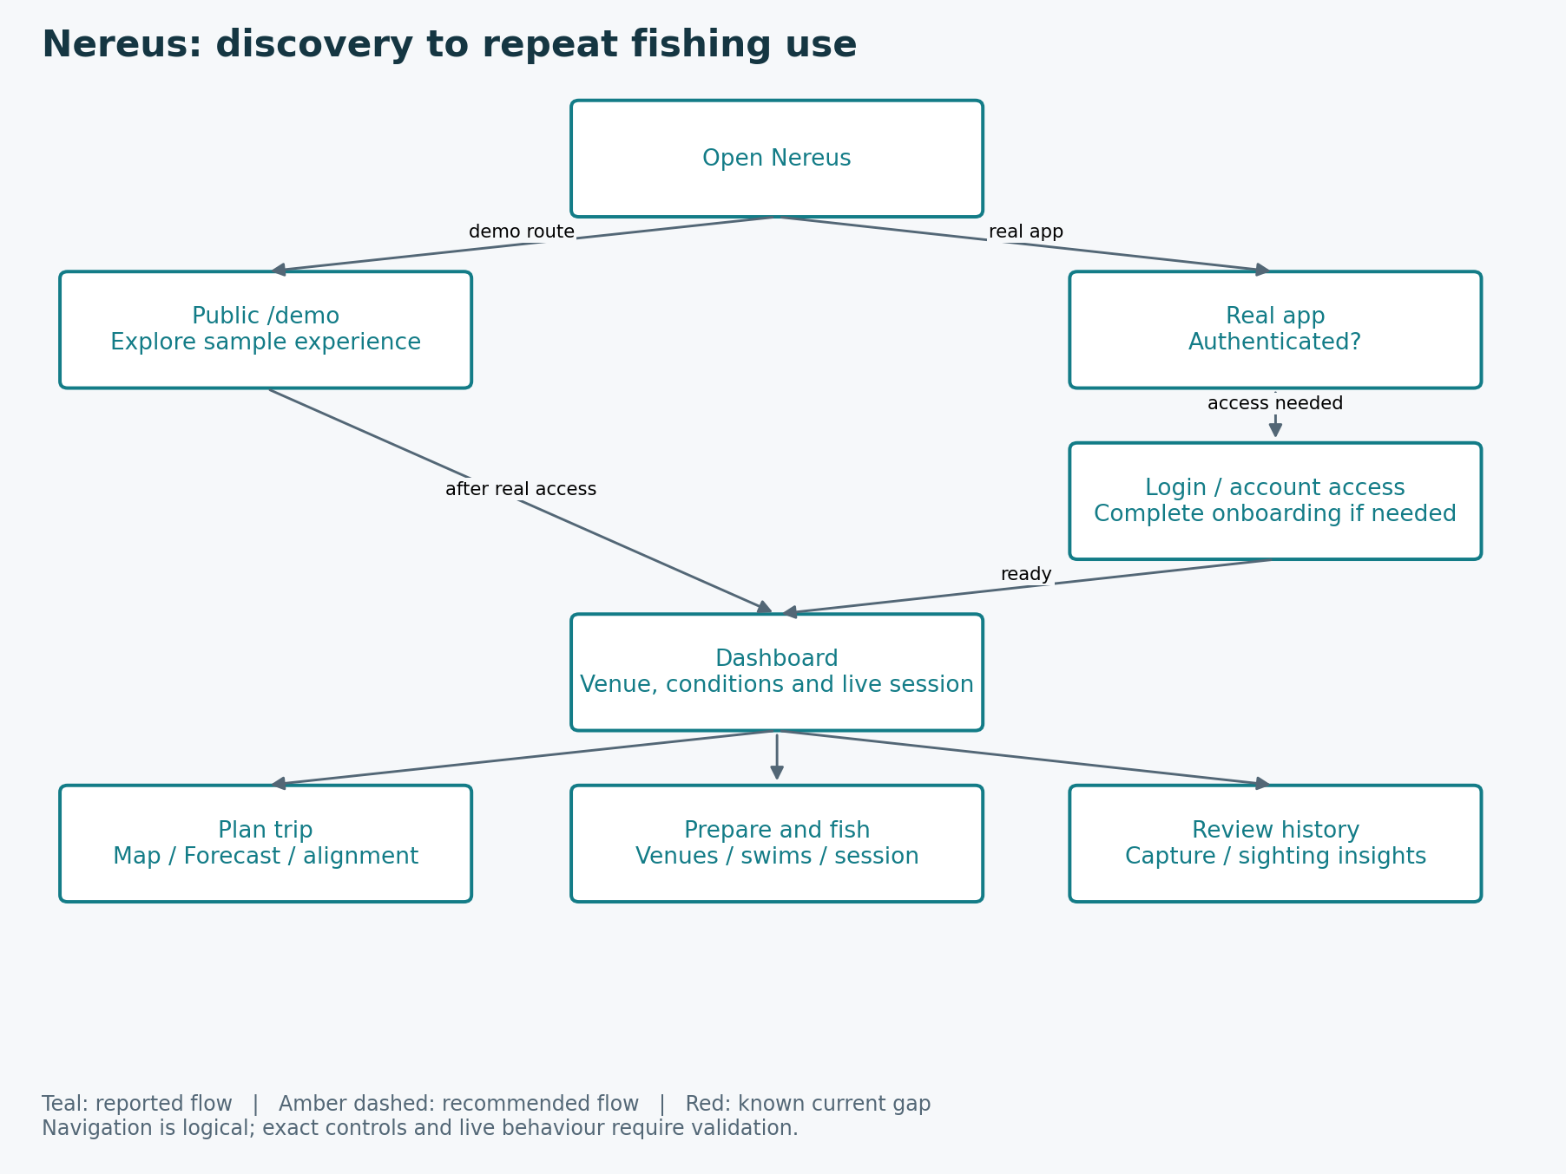
Current overview: reported discovery and fishing paths only. “After real access” requires real authentication/onboarding; the demo does not grant access to a real account.

A1. Current screen inventory
Route | Current purpose
/demo | Public discovery
/Dashboard | Home, venue context and active-session entry
/Map | 24-hour / seven-day tactical map
/Forecast | Forecast blocks and condition alignment
/Log | Venue management
/Insights | Aggregate signals; role and plan visibility to confirm
/Pricing | Plan selection
/session | Active fishing session
/venue-detail | Venue workspace
/alignment-detail | Alignment explanation
/swim-detail | Swim workspace
/bait-up | Baiting record
/spot-detail | Spot context
/sighting-insights | Sighting patterns
/capture-insights | Capture patterns

15 routable screens; 16 page components. OAuthConsent.jsx is reported unmounted. / redirects to /Dashboard and * shows 404. There is no identified dedicated admin portal or billing-management route.

A1. Discover Nereus through the public demo
Classification: CURRENT — reported
User goal: Visitor wants to assess the application before committing.
- Open /demo.
- Explore the mocked dashboard, map, log and forecast experience.
- Attempting restricted actions shows a demo prompt rather than creating real fishing records.
Current limitations / unverified behaviour: The exact demo-to-account action and destination are unverified. Demo previews are not real customer history.

A2. Authenticate and complete onboarding
Classification: CURRENT — reported
User goal: New or returning angler opens the real application.
- Open the root or a real app route; splash/loading appears while account access is checked.
- If unauthenticated, follow the Base44 login flow. Account creation depends on the configured provider experience.
- If authenticated but onboarding is incomplete, set profile/preferences and create or select initial venue context.
- Persist the onboarding state and arrive at /Dashboard; already-onboarded users proceed to the dashboard.
Current limitations / unverified behaviour: Exact signup/recovery configuration, partial onboarding persistence and deep-link return behaviour remain unverified.

A3. Orient on the dashboard and choose a venue
Classification: CURRENT — reported
User goal: Returning angler wants a quick view of conditions and current fishing context.
- Open /Dashboard after authentication.
- Load the active/default venue, current or near-term conditions and activity/alignment signals.
- Switch venue when needed and inspect available alerts.
- Resume an active session or choose a map, forecast, log or insight journey.
Current limitations / unverified behaviour: Weather fetching sometimes fails according to Mark; freshness indicators and recovery behaviour are unverified.

A4. Create and organise venue, swim and spot context
Classification: CURRENT — reported
User goal: Angler prepares reusable location information.
- Open /Log and select an existing venue or create one.
- Set a default venue if appropriate and open /venue-detail.
- Create/select a swim and open /swim-detail.
- Add relevant notes, photographs/annotations and spots; inspect /spot-detail.
- Return to the venue workspace to review history or start fishing.
Current limitations / unverified behaviour: Exact required fields, ownership enforcement in all paths, detail parameters and upload failure handling require validation.

A5. Plan a trip using weather, map and alignment
Classification: CURRENT — reported
User goal: Angler decides when and where to fish.
- Select the intended venue and open /Forecast.
- Review the seven-day day/night forecast, moon context and activity/alignment signals.
- Open /alignment-detail to investigate an alignment result.
- Use /Map for 24-hour influence or seven-day strategic context, comparing swims/spots with conditions.
- Use the findings to choose a fishing opportunity and proceed to venue/session preparation.
Current limitations / unverified behaviour: Weather reliability and data accuracy are concerns. Forecast/insight quality has not been independently demonstrated. No booking or saved-trip feature is established.

A6. Record baiting activity
Classification: CURRENT — reported
User goal: Angler wants to retain baiting history for a swim or area.
- Select a venue/swim context.
- Open /bait-up.
- Enter supported baiting details and areas/items.
- Save and confirm that the record appears in the intended context.
- Continue to swim preparation, active fishing or historical review.
Current limitations / unverified behaviour: Exact baiting fields, editing and relation to sessions are not fully supplied.

A7. Start, resume and complete a fishing session
Classification: CURRENT — reported
User goal: Angler wants reliable live logging while fishing.
- Start or resume a session from the venue/swim context or dashboard shortcut.
- Open /session and confirm the correct venue/swim and active session state.
- Record captures, bites and sightings; maintain rod setup and relevant bait context.
- Move swim where supported while retaining session continuity.
- End the session and persist it as historical data.
- Review related capture/sighting patterns and use the results for the next trip.
Current limitations / unverified behaviour: Persistence after loss of signal, reload or app closure is unverified. A durable offline write queue is not established.
Existing records are intended to support history and insights; this is not evidence that interruption/offline scenarios have passed testing.

A8. Review patterns and personalise intelligence
Classification: CURRENT — reported
User goal: Angler wants to learn from previous successes and failures.
- Open the available insight links from dashboard or venue context.
- Use /capture-insights to inspect catch patterns and /sighting-insights to inspect observations.
- Review available aggregate /Insights information where the account is authorised.
- Compare time, wind, temperature, pressure, moon and relevant venue context.
- Adjust supported activity preferences/personal calibration and revisit future alignment.
Current limitations / unverified behaviour: /Insights role/tier visibility and exact filtering controls need confirmation; prediction accuracy is not proven.

A9. Share and receive venue information
Classification: CURRENT — reported
User goal: Angler intentionally shares a venue/swim snapshot.
- Sender chooses the available sharing action in venue context and creates an invitation.
- Recipient encounters the invitation through the implemented delivery mechanism; exact email/in-app channel is not established.
- Recipient accepts or declines; sender may cancel a pending invitation.
- Acceptance copies the allowed snapshot and associated media to recipient context.
- Expired/cancelled invitations are no longer actionable; confirm successful receipt in the recipient workspace.
Current limitations / unverified behaviour: Delivery channel and exact snapshot contents are unverified. Remote photo copying and missing-tier Elite fallback are reported security/entitlement concerns.

A10. Upgrade membership and manage billing
Classification: CURRENT — reported / known gap
User goal: Angler wants paid functionality and a clear subscription lifecycle.
- Open /Pricing, which defines Explorer free, Intelligence £6/month and Elite £8/month.
- The current getUserTier() override reports Elite for every user. Pricing can therefore regard users as already upgraded and hide normal upgrade actions.
- The createCheckoutSession backend function exists and creates a Stripe subscription Checkout Session using hardcoded prices; ordinary UI availability and live checkout are unverified.
- The webhook handles checkout.session.completed and customer.subscription.updated/deleted, verifies signatures and updates User.membership_tier.
- The frontend ignores the stored membership tier because of the override. The paid journey is not production-ready end to end.
Current limitations / unverified behaviour: Known blocker: all users are treated as Elite. Live secrets, Price IDs, redirects and lifecycle behaviour are unverified. No customer billing-management flow is reported.

A11. Current account roles and connectivity
Admins reportedly share the customer dashboard shell and have additional navigation. That is current role-specific behaviour, not the proposed business portal. Some localStorage/sessionStorage caches exist; that does not demonstrate offline recording, reconnect synchronisation or background notifications.
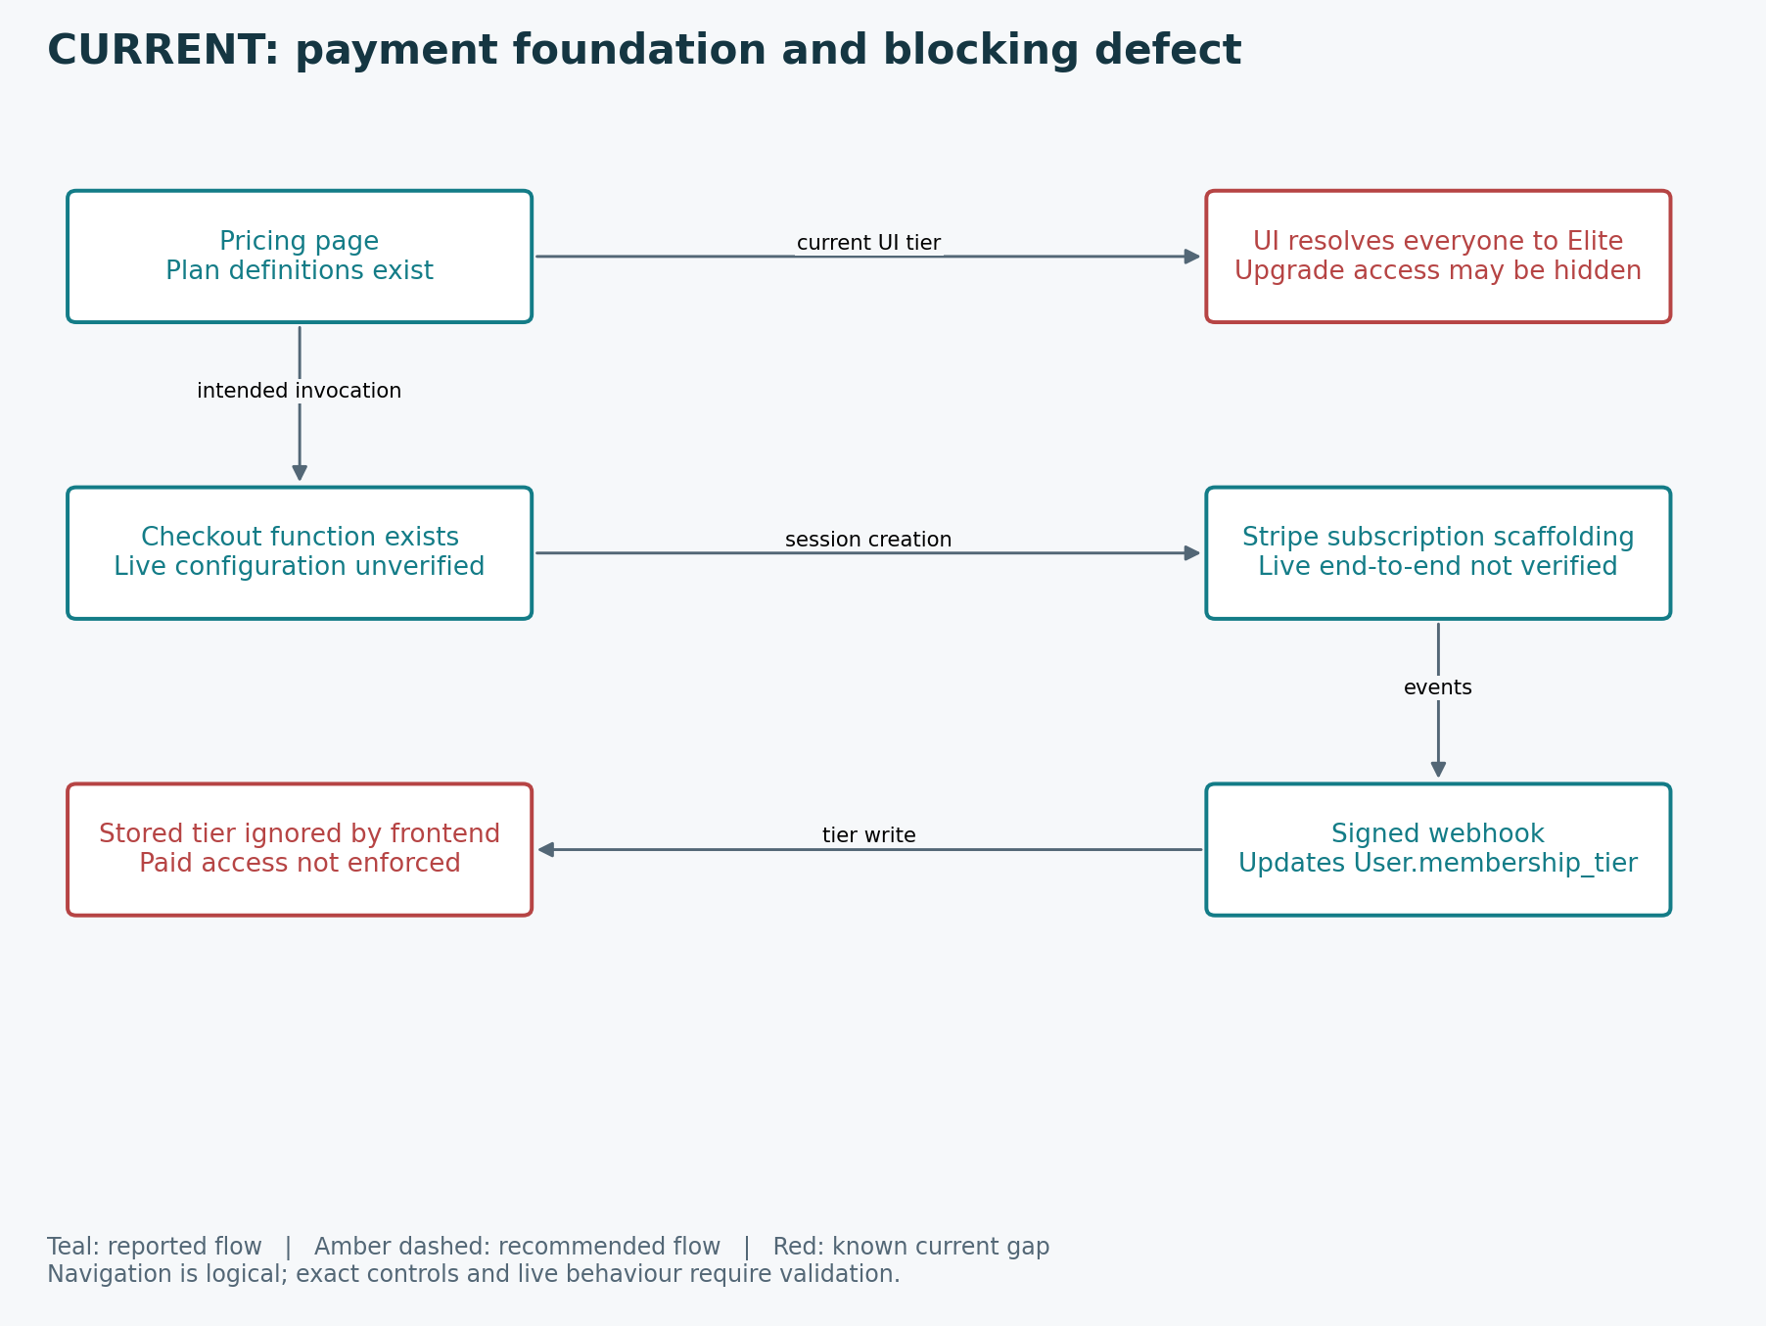
Current billing flow only. No customer portal, corrected entitlement or successful live payment result is implied.

PART B — Proposed User Journey Flow
The proposed experience preserves the current fishing loop and corrects its reliability and access gaps. New offline recovery, customer billing management, business admin and native notification capabilities are additions requiring scope and implementation. These journeys are target behaviour, not completed features.
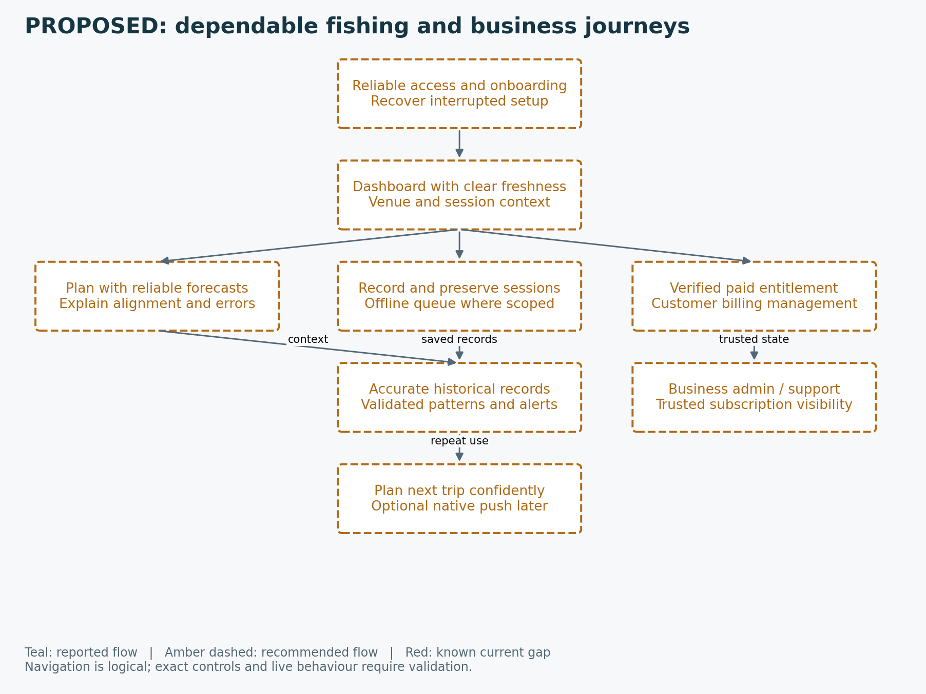
Proposed overview: all amber components express target improvements. Core fishing functions already exist; these nodes describe their intended refined behaviour.

B1. Discover Nereus through the public demo
Classification: PROPOSED — REFINEMENT OF CURRENT FLOW
Target user outcome: Visitor understands the product and can proceed to real access without mistaking sample history for personal records.
Retain the reported current journey from Part A. Improve its failure/recovery behaviour as follows: Demo isolation, unsupported navigation and exit conversion need testing. Never carry a mocked identity or Elite entitlement into a real account.
Acceptance criteria for delivery: Demo loads without login; unsupported actions cannot mutate real records; real access uses actual authentication.
Proposed conversion: provide a clear demo-to-real-account action, require real access/onboarding and prevent mock data or identity becoming real customer state.

B2. Authenticate and complete onboarding
Classification: PROPOSED — REFINEMENT OF CURRENT FLOW
Target user outcome: An authenticated account is ready to use Nereus with usable venue context.
Retain the reported current journey from Part A. Improve its failure/recovery behaviour as follows: Handle failed authentication, expired sessions, abandoned onboarding and incomplete saves with retry/re-entry paths. These recovery behaviours are recommendations until verified.
Acceptance criteria for delivery: Returning users avoid unnecessary onboarding; partial setup does not masquerade as complete; denied access never loads another account’s records.

B3. Orient on the dashboard and choose a venue
Classification: PROPOSED — REFINEMENT OF CURRENT FLOW
Target user outcome: The user knows which venue the information describes and what to do next.
Retain the reported current journey from Part A. Improve its failure/recovery behaviour as follows: Missing venue, loading failure, stale forecast and empty history should be explicit. Avoid presenting stale information as current. Minimum loading and error behaviour needs verification.
Acceptance criteria for delivery: Venue switches update dependent conditions consistently; active-session links resume the correct record; data freshness is visible.

B4. Create and organise venue, swim and spot context
Classification: PROPOSED — REFINEMENT OF CURRENT FLOW
Target user outcome: A private venue workspace captures useful fishing positions and context.
Retain the reported current journey from Part A. Improve its failure/recovery behaviour as follows: Validate ownership, coordinates and parent associations. Missing or deleted IDs should lead to a useful fallback. Upload failures should be recoverable without losing other edits.
Acceptance criteria for delivery: Records remain attached to the intended venue/swim; account A cannot access account B’s private locations; failed media uploads are clearly reported.

B5. Plan a trip using weather, map and alignment
Classification: PROPOSED — REFINEMENT OF CURRENT FLOW
Target user outcome: The user can make an informed decision supported by conditions and personal history.
Retain the reported current journey from Part A. Improve its failure/recovery behaviour as follows: Do not invent a booking, calendar or saved-trip feature: none is established. Upstream failures, invalid location, units, timezone and insufficient history need understandable handling.
Acceptance criteria for delivery: Dashboard/forecast/map agree on venue and time context; unavailable or stale forecasts are labelled; alignment is explainable rather than treated as certain success.

B6. Record baiting activity
Classification: PROPOSED — REFINEMENT OF CURRENT FLOW
Target user outcome: Baiting history is retained and associated with the correct place.
Retain the reported current journey from Part A. Improve its failure/recovery behaviour as follows: Exact fields, quantities, editing behaviour and relationships to sessions are unverified. Preserve entry data through recoverable validation failures as a recommended behaviour.
Acceptance criteria for delivery: Successful save is visible; invalid input does not create misleading records; unrelated users cannot read or edit the entry.

B7. Start, resume and complete a fishing session
Classification: PROPOSED — REFINEMENT OF CURRENT FLOW
Target user outcome: Fishing activity becomes dependable private history rather than isolated notes.
Retain the reported current journey from Part A. Improve its failure/recovery behaviour as follows: Test reload, accidental close, failed save and reconnect. A complete durable offline queue is not confirmed. Prevent accidental duplicate sessions/events and do not claim an entry saved until persistence is known.
Acceptance criteria for delivery: Resume opens the same session; records survive validated interruption scenarios; ending a session preserves history and does not silently drop entries.

B8. Review patterns and personalise intelligence
Classification: PROPOSED — REFINEMENT OF CURRENT FLOW
Target user outcome: History helps the angler plan future sessions with understandable context.
Retain the reported current journey from Part A. Improve its failure/recovery behaviour as follows: Exact filtering controls and accuracy are unverified. Confirm whether /Insights is admin-only, paid-member access or mixed. Limited history should not produce false confidence.
Acceptance criteria for delivery: Known-data calculations are consistent; insufficient data is explained; actual permissions agree with navigation and direct-route access.
Define low-history/insufficient-data behaviour and validate scoring rules. Proactive push delivery is a separate later capability; no trained AI model is established.

B9. Share and receive venue information
Classification: PROPOSED — REFINEMENT OF CURRENT FLOW
Target user outcome: The recipient receives deliberately shared information without access to unrelated private history.
Retain the reported current journey from Part A. Improve its failure/recovery behaviour as follows: Sharing is reported as snapshot copying, not continuous collaborative synchronisation. Harden remote photo fetching; confirm limits and expiry states. Missing-tier fallback currently defaults to Elite and needs correction.
Acceptance criteria for delivery: Only authorised parties act on invites; acceptance is repeat-safe; expired invitations fail clearly; copied images are bounded and trusted.

B10. Upgrade membership and manage billing
Classification: PROPOSED — FIX + NEW BILLING MANAGEMENT
Target user outcome: Paid access and account display reflect verified subscription state.
- Open /Pricing and compare Explorer (free), Intelligence (£6/month) and Elite (£8/month).
- Select a paid plan in the intended corrected UI; createCheckoutSession returns Stripe checkout.
- Complete hosted checkout or cancel; only verified payment/subscription state should alter entitlement.
- Signed Stripe events update trusted User.membership_tier; the app refreshes account state.
- Use the recommended customer billing-management flow to manage card, invoices and cancellation.
- Apply the agreed renewal, upgrade/downgrade, failure and expiry rules.
First correct the Elite override and sharing fallback. Enforce entitlement in backend operations and protect trusted membership writes. Customer portal/self-service must then be added; the success redirect alone must never grant paid access.
Acceptance criteria for delivery: Correct plan grants correct access; direct backend calls enforce entitlement; delayed/duplicate events are safe; cancellation-at-period-end is distinct from immediate expiry.
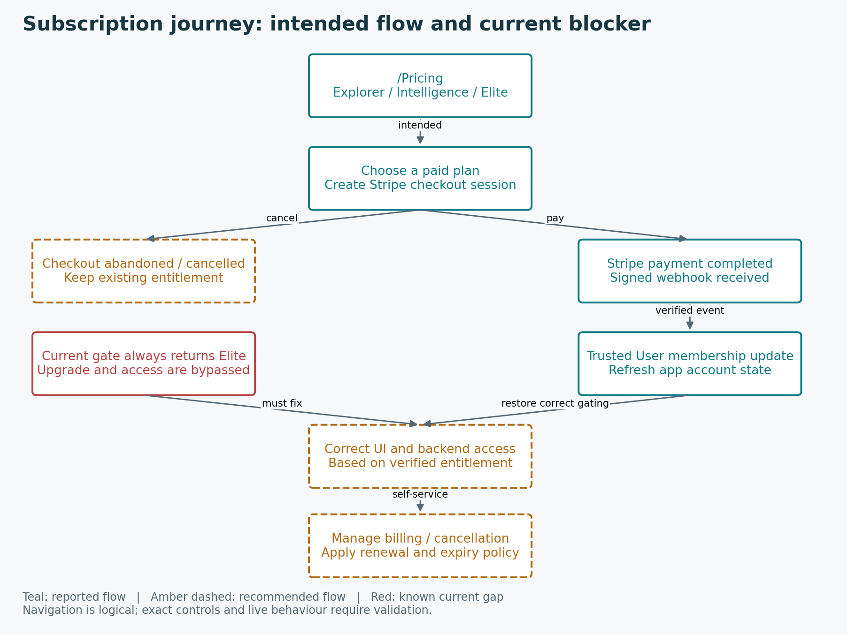
Proposed billing journey and required correction. Amber access/customer management remains to be delivered; red identifies the existing blocker.

B11. Recover from poor connectivity and unavailable data
Classification: PROPOSED — NEW CAPABILITY
Target user outcome: Essential field activity remains usable without misrepresenting freshness or losing records.
- If online data fails, show a clear connection/data status.
- Where available, display cached venue/history and labelled weather timestamps.
- For the proposed offline extension, store new activity in a durable pending queue.
- Reconnect, reauthenticate if necessary, synchronise and confirm completed writes.
- Resolve conflicts or duplicates explicitly, then refresh current weather.
Acceptance criteria for delivery: Supported offline journeys survive restart/reconnect; unsynced records are visible; no duplicate writes; unavailable live forecasts are never labelled current.

B12. Admin support and business oversight
Classification: PROPOSED — NEW CAPABILITY
Target user outcome: Operators can understand the business and support customers through controlled access.
- Authenticate with a trusted administrative role.
- Open proposed dashboard and inspect defined user/activity metrics and measured system health.
- Search users and review limited support context and verified billing state.
- Apply controlled suspension/reactivation or approved support actions.
- Record sensitive actions in audit history and verify their effect.
Acceptance criteria for delivery: Ordinary users cannot invoke admin APIs; metrics have defined sources; suspension is backend-enforced; privileged actions are auditable.

PART C — Current-to-proposed change register
Area | Current state | Proposed change
Core fishing | Venues, swims, spots, baiting, sessions, history and insights reported | Stabilise persistence, validate calculations and improve error states.
Authentication | Base44 checks and onboarding reported | Verify recovery, partial onboarding and account isolation.
Conditions | Map/forecast/weather functions reported; failures reported | Freshness labels, reliable fetch/retry and understandable fallback.
Membership | Stripe scaffold + always-Elite frontend | Trusted UI/backend entitlement and full lifecycle validation.
Billing support | Customer portal not reported | Manage payment details, invoices and approved cancellation/plan changes.
Venue sharing | Snapshot invites/copying reported | Secure media fetching, invitation states and actual tier restrictions.
Offline | Browser caches reported; complete sync unverified | Durable queued records, clear pending status and safe reconnect.
Administration | Additional admin navigation reported | Dedicated protected business portal and auditable support.
Notifications/native | Dynamic alerts reported; native goal stated | Scope proactive push and native clients separately.
Failure handling | Completeness unverified | Standard loading, empty, denied, stale, unsaved and retry states.

PART D — Validation, decisions and release boundaries
Current flow descriptions are not live Pass results. Record environment/version, journey, expected/actual behaviour, evidence, severity and retest outcome when testing. Use two ordinary accounts and an admin; include outdoor readability and intermittent signal.
Resolve final plan benefits/limits, /Insights permissions, onboarding and account recovery behaviour, share-delivery channel, minimum offline scope, cancellation/grace/downgrade policy and supported devices. Confirm account export/deletion and support flows before classifying them as current features.
Immediate delivery should protect private records and roles, correct paid access, preserve fishing activity and make weather failures understandable. Admin belongs in early foundations; billing management follows verified subscription state. Offline and native scope must be expressly decided rather than implied as launch-complete.
Proposed success measures: onboarding completion, first venue/session, save success, forecast-fetch success, share acceptance, checkout completion and repeat use. These are measurement recommendations, not existing business metrics. Exclude demo/test data and minimise collection of private fishing information.

